Ex.No.11: Implementation of IoT-based Smart Agriculture using MATLAB
AIM: To design and simulate an IoT-based smart agriculture system using MATLAB by
monitoring soil moisture levels, controlling water pump status (ON/OFF), and evaluating
irrigation efficiency for optimized water resource management.
Objective – 1: To monitor the Soil Moisture (%) level in agricultural fields using IoT-based sensing simulation in MATLAB.
Program:
clc; clear; close all;
% Simulated soil moisture data (%)
time = 1:10;
soil_moisture = [30 35 28 25 20 18 22 30 40 45];
% Threshold for irrigation
threshold = 40;
figure
% -------- Graph 1: Soil Moisture Variation --------
subplot(2,1,1)
plot(time, soil_moisture, '-o', 'LineWidth', 2)
title('Soil Moisture Monitoring in IoT Smart Agriculture')
xlabel('Time (Hours)')
ylabel('Soil Moisture (%)')

grid on
hold on
yline(threshold,'r--','Threshold')
% -------- Graph 2: Moisture Status (Dry/Wet Level) --------
status = soil_moisture >= threshold;
subplot(2,1,2)
stem(time, status, 'filled', 'LineWidth', 2)
title('Soil Condition Status (1=Wet, 0=Dry)')
xlabel('Time (Hours)')
ylabel('Status')
grid on
OUTPUT 1:
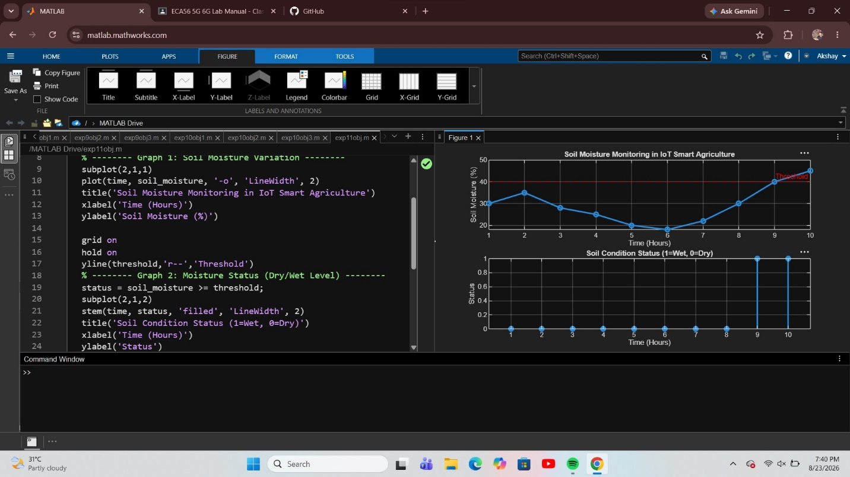

Objective 2: To control and display the Water Pump Status (ON/OFF) based on threshold soilmoisture conditions. To control and display the Water Pump Status (ON/OFF) based on threshold soilmoisture conditions.

Program:
clc; clear; close all;
% Simulated soil moisture (%)
time = 1:10;
soil_moisture = [30 35 28 25 20 18 22 30 40 45];
% Threshold level
threshold = 40;

% Pump control logic (1 = ON, 0 = OFF)
pump_status = soil_moisture < threshold;
figure
% -------- Graph 1: Soil Moisture vs Pump Status --------
subplot(2,1,1)
plot(time, soil_moisture, '-o','LineWidth',2)
title('Soil Moisture vs Pump Control')
xlabel('Time (Hours)')
ylabel('Soil Moisture (%)')
grid on
hold on
yline(threshold,'r--','Threshold')
% -------- Graph 2: Pump Status (ON/OFF) --------
subplot(2,1,2)
stem(time, pump_status, 'filled','LineWidth',2)
title('Water Pump Status (1=ON, 0=OFF)')
xlabel('Time (Hours)')
ylabel('Pump Status')
grid on
Output 2:
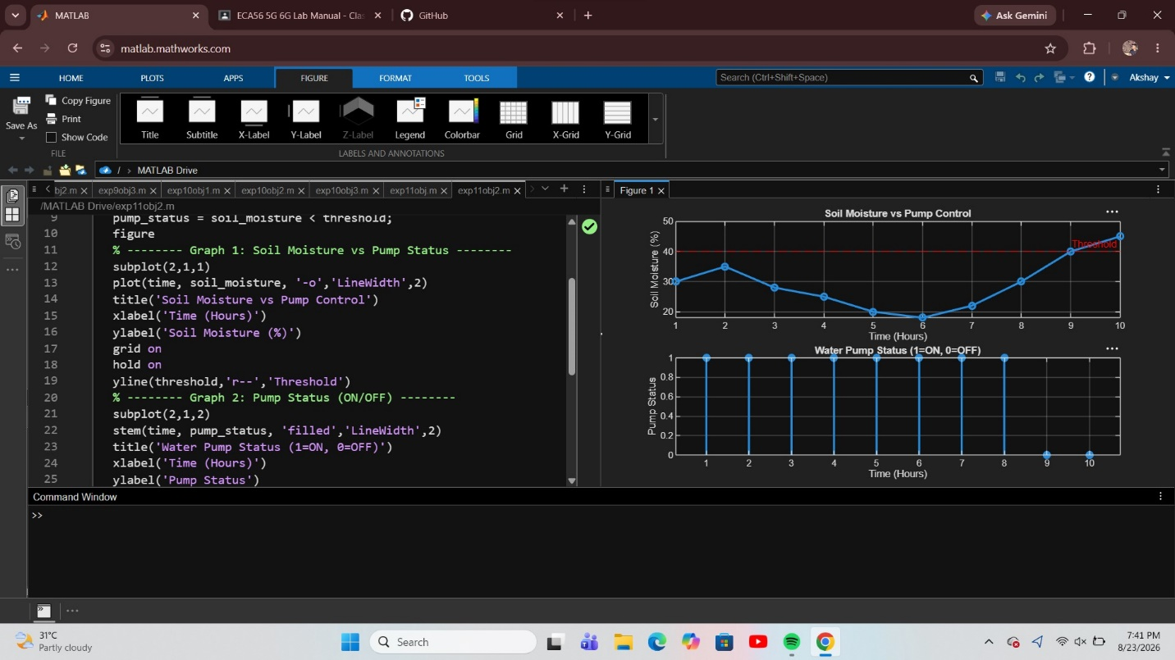
Objective 3: To evaluate the Irrigation Efficiency (%) by analyzing water usage effectiveness and moisture maintenance level.
Program:
clc; clear; close all;
% Simulated soil moisture data (%)
time = 1:10;
soil_moisture = [30 35 28 25 20 18 22 30 40 45];
% Threshold level
threshold = 40;
% Irrigation efficiency calculation (%)
efficiency = (soil_moisture ./ threshold) * 100;
efficiency(efficiency > 100) = 100; % limit to 100%
figure
% -------- Graph 1: Soil Moisture vs Efficiency --------
subplot(2,1,1)
plot(time, soil_moisture, '-o','LineWidth',2)
title('Soil Moisture Variation')
xlabel('Time (Hours)')
ylabel('Soil Moisture (%)')
grid on
hold on
yline(threshold,'r--','Threshold')
% -------- Graph 2: Irrigation Efficiency --------
subplot(2,1,2)
plot(time, efficiency, '-s','LineWidth',2)
title('Irrigation Efficiency (%) in Smart Agriculture')
xlabel('Time (Hours)')
ylabel('Efficiency (%)')
grid on
OUTPUT 3:
